**Turning Data into a Map with QGIS**. Does your data have a 'where'?

**Setting up a spreadsheet**

Your spreadsheet must contain not just everything you want to map, but any labels you are planning to use to annotate your points, or categories you want to group them in.

|  |  |  |  |  |  |  |
| --- | --- | --- | --- | --- | --- | --- |
| ID | Longitude | Latitude | Race | Gender | Occupation | Marital |
| 1 | -90.05674050000 | 29.96555400000 | W | M | Clerk | S |
| 2 | -90.07316100000 | 29.95117200000 | W | M | Laborer | M |
| 3 | -90.07586800000 | 29.95393900000 | B | M | Laborer | S |
| 4 | -90.07157000000 | 29.95939300000 | B | F | Laundress | S |
| 5 | -90.07445515750 | 29.95245642810 | B | F | Housekeeper | M |

Hints:

Column names should be short, sweet, & avoid weird characters and spaces

!@#$%^&*()

Is my Latitude positive or negative? What about the Longitude?

+ Latitude

- Longitude

+Latitude

+Longitude

-Latitude

-Longitude

-Latitude

+Longitude

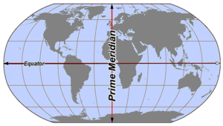

Save your spreadsheet as a .csv (comma separated values)

**Adding data to a QGIS project**

OK, so let’s get started. Open the QGIS Desktop (this tutorial was written for version 2.18.13, other 2.18 and 3.0.0 versions may look a little different).

There are 3 ways to load data into QGIS. Choose the one that you like best. The first is by using the widgets on the left hand side of the screen. Choose the one that matches the type of data you want to import. If you hover over each one, a popup will tell you the corresponding data type. Browse to the location of your data and click Open.

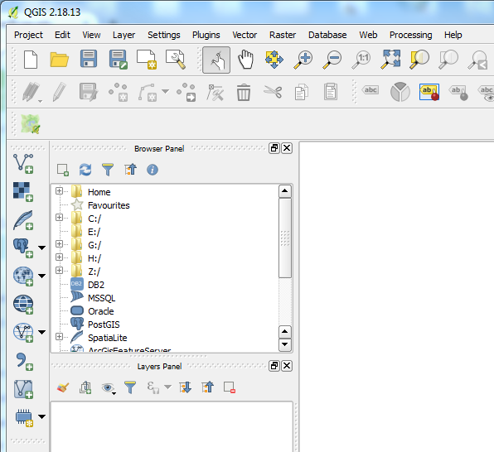

**Method 2**

**Method 1**

The second way is to use the Browser Panel. Expand the folders to locate the one with your data, click on the name of the file and drag the file into the map document to the right of the panel (the big empty white space).

The third method is to use the Layer Menu option, select the type of file you wish to load and follow the prompts to its location.

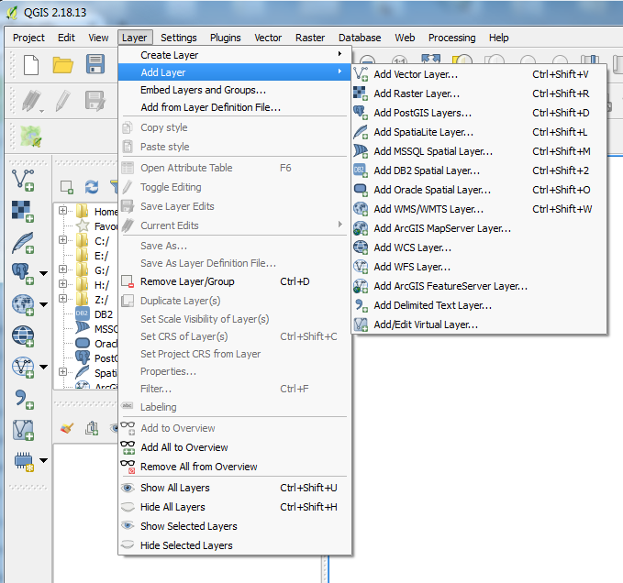

**Method 3**

Ok, you caught me, there’s a **4th** way. You can use these shortcuts.

We’re going to use the first method. Because our data is in a .csv, click on the giant “**,**” and this dialog box will open. If our data was a shapefile we would use the **Add vector layer** button (at the top), for a raster image, we would use the second button (looks like a checkerboard).

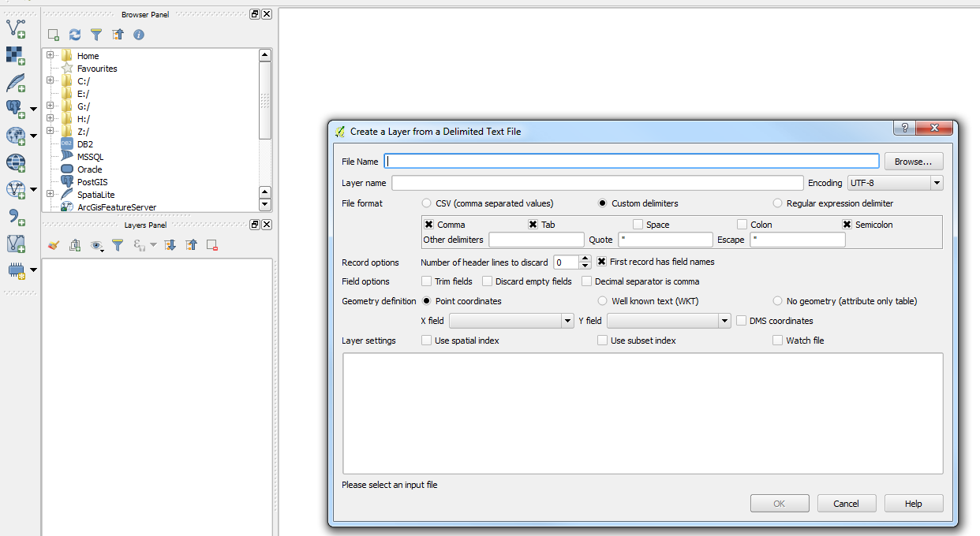

Browse for your .csv file and click Open. QGIS will read your file and make some pretty good guesses what everything is. If it looks good, click OK, if not adjust as needed.

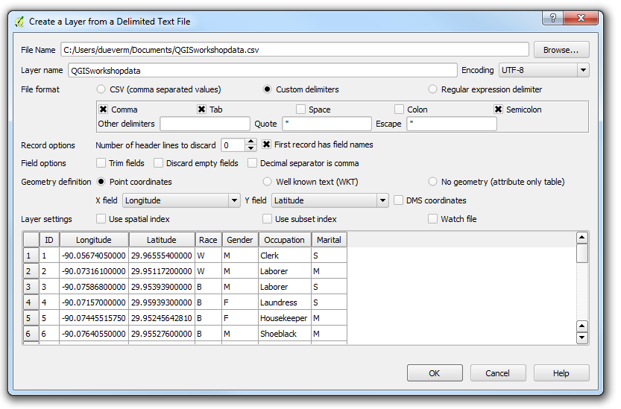

Once you click OK, a new dialog box will open asking for the coordinate system of your data. If you got your coordinates from Google Maps, Getty, your GPS, or they were geocoded by ESRI or another geocoding service, WGS 84 (EPSG:4326) is what you should select. You can use Filter to search for WGS 84 if it is not already visible.

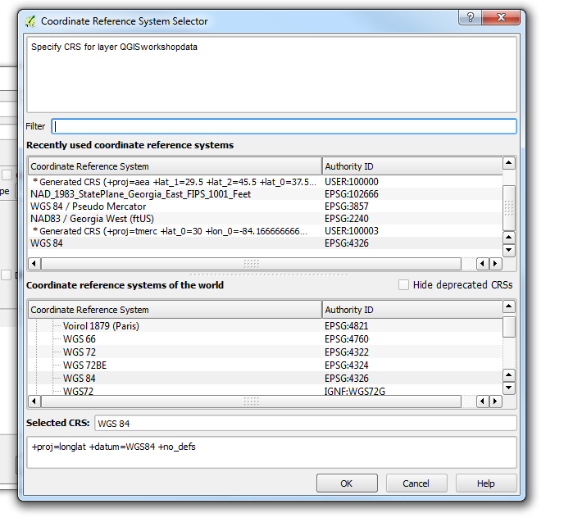

After selecting your coordinate reference system, click OK and your location(s) from your spreadsheet will appear in the project space.

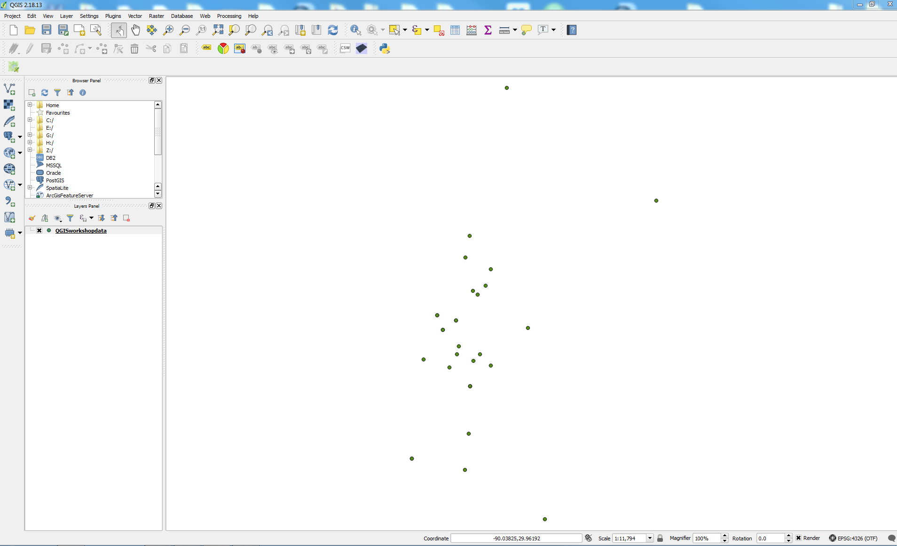

**Saving your new shapefile**

If you would like to reuse the points you just created in another project or map later on, you will need to save them. Right now they exist only in the current QGIS project. If you were to exit QGIS (or it were to crash on you), you would have to recreate the points. To save the points, right click on the name of the file in the Layers Panel and select Save As…

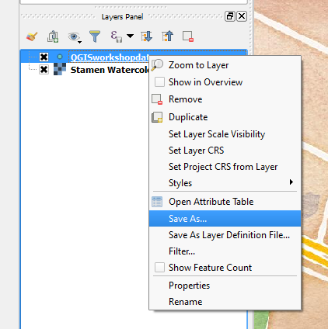 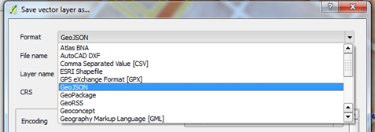

This will bring up the Save vector Layer as… dialog box. First select your format. QGIS defaults to a GeoJSON, but a shapefile is also an option (these are the 2 most people will be familiar with.

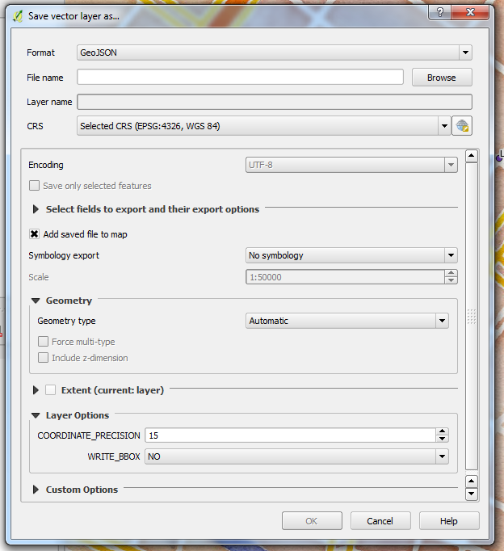

If you want to change the CRS for your new shapefile/GeoJSON layer, click on the icon after the dropdown arrow on the CRS line.

Click Browse to direct QGIS where to store your new file, then enter a Layer name – this is the name of your new file.

Click OK and your new layer will be added to the map. Right click on the old file and select Remove. Our map is looking a little sad, so let’s go ahead and add a Basemap.

**Adding a basemap**

Before we can add a web-based basemap, we need to enable the right Plugin. From the top menu, click on the Plugins option. Then Search for the OpenLayers Plugin and install it if it is not already installed.

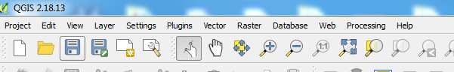

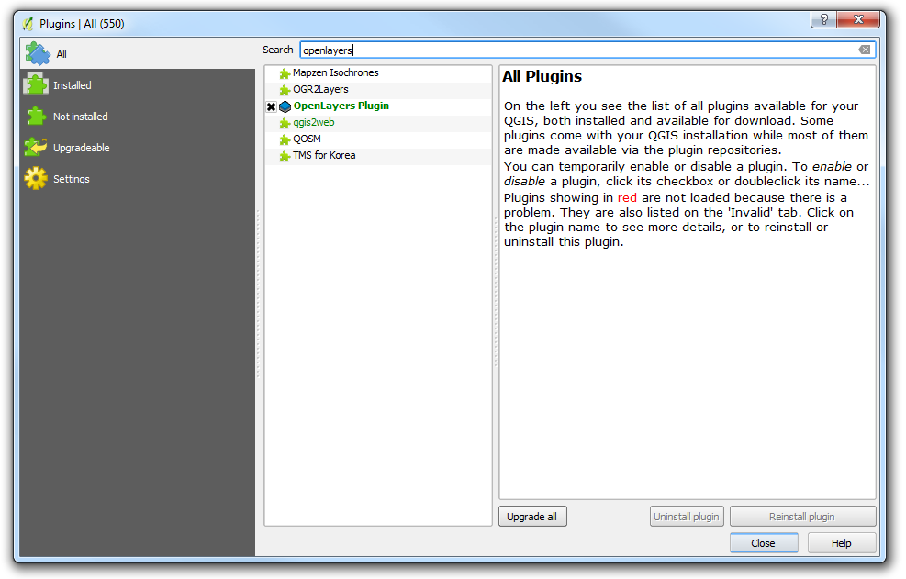

The OpenLayers plugin will give us access to OpenStreetMap, Google Maps, and Bing Maps if you would like to show streets or the physical environment, but you also have access to Stamen maps that offer a more artistic rendering. To access the plugin, click on Web from the top menu.

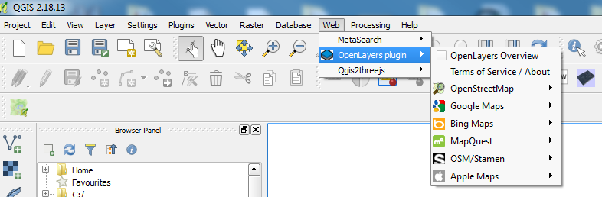

Once you choose your basemap, it’ll be added to the map. You can pick a new basemap at any time, just Remove the old one by right clicking on the name of the layer in the Laer Panel and choosing Remove.

You might notice that your points have disappeared once you added the basemap.

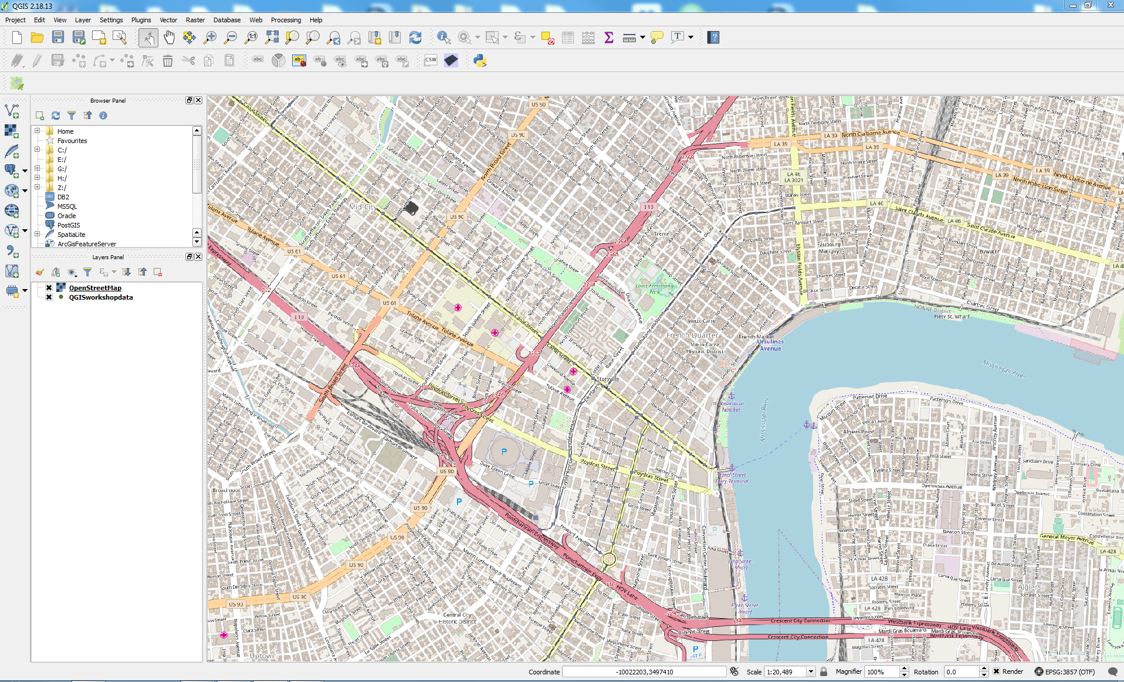

That’s because the basemap is on top of your points. Click and drag your point shapefile in the Layers Panel back on top of the basemap and your points will reappear.

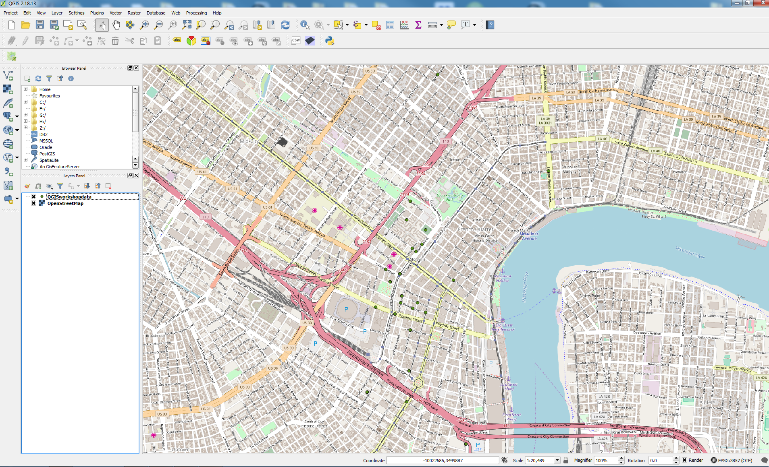

**Styling your points**

When QGIS initially draws a feature on the map, it randomly selects a color for it. We can change the color and the symbol by right clicking on the name of our file in the Layers Panel and selecting Properties from the menu.

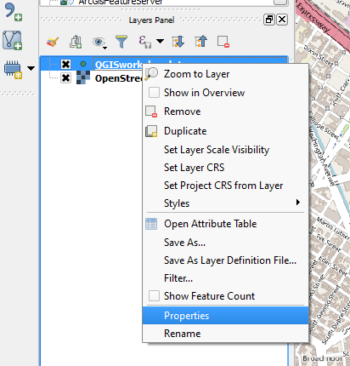

The Layer Properties dialog box covers several topics. We are interested in the Style sub-menu (we’ll get to Labels later). This is what the box looks like when you first open it.

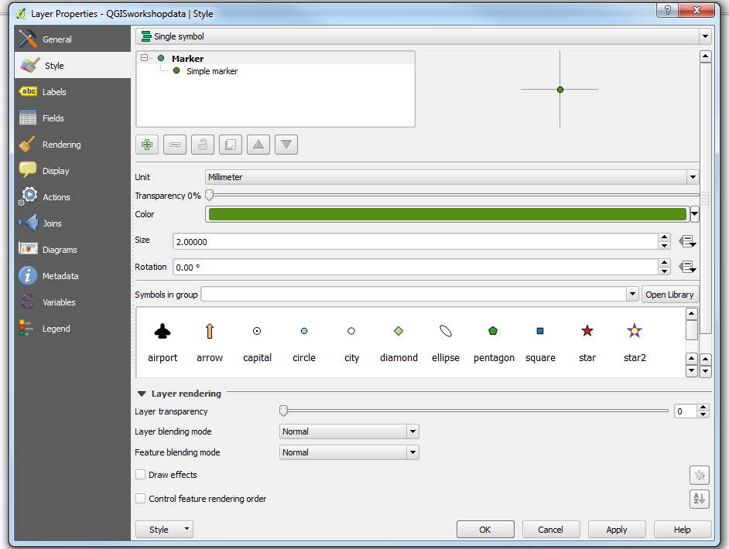

You can pick a new color, a bigger size, or a different symbol to represent your points. There’s even a Library you can open that has more options. You can click Apply and your map will update with the changes without closing the dialog box. When you are happy with your changes, click OK.

We can also change the color of the points based on a value or category that we included in our spreadsheet.

At the very top of the box, on the far right there is a dropdown arrow that we can use to choose to categorize our points.

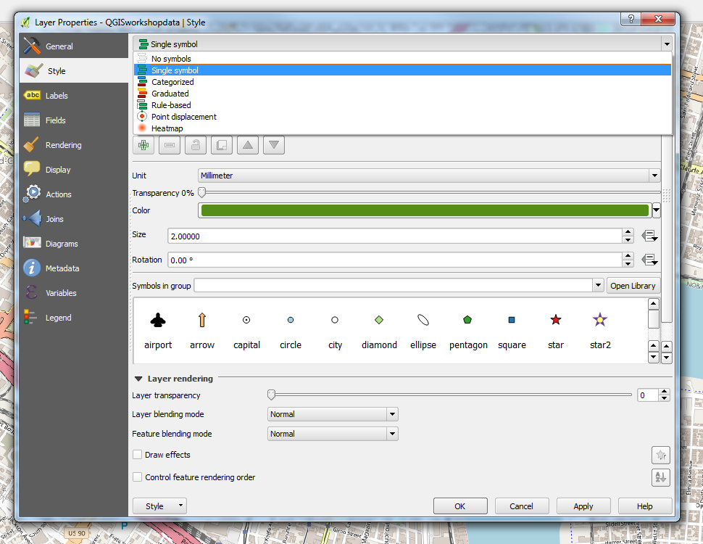

Once we change our Single Symbol to Categorized, we get new options. One is picking the Column we want to base our categories on. We can change the symbol to something other than a dot.

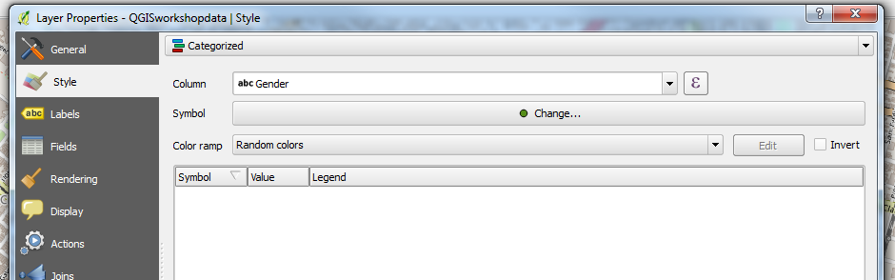

Click on the Classify button to get the list of values in the Column you chose.

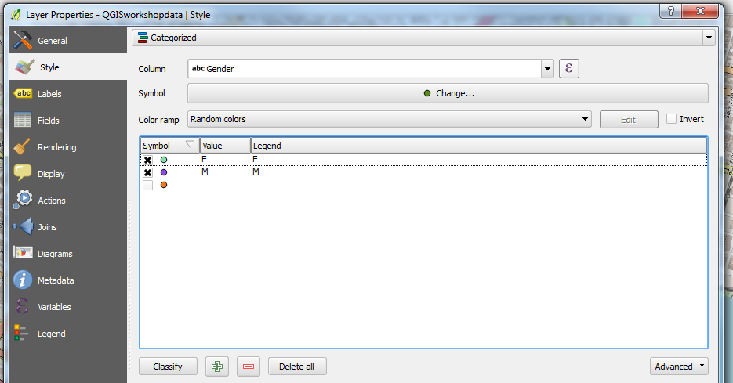

You can turn off (by clicking on the X next to the symbol) or even delete items (using the big red minus symbol). If you want to change the labels that will be used in your Legend, double click on the word under Legend that you want to change and type the new one.

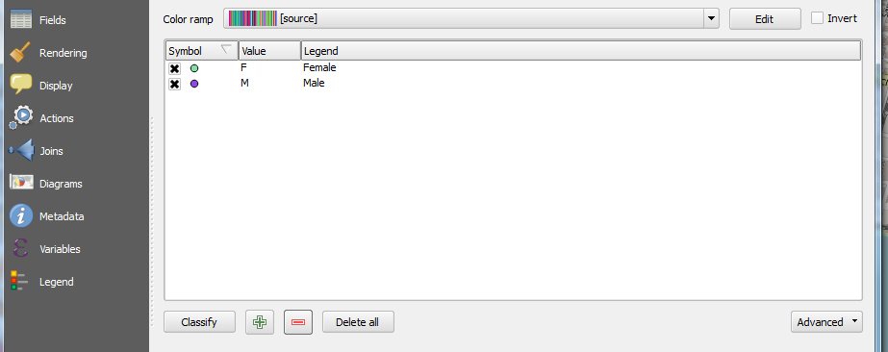

Click Apply to see how the changes look and OK when you are done.

**Labeling**

As mentioned previously, you can add and style your Labels through the Properties of your layer.



Right click on the name of your shapefile and select Properties, then select the Labels tab on the left. The default is No Labels.

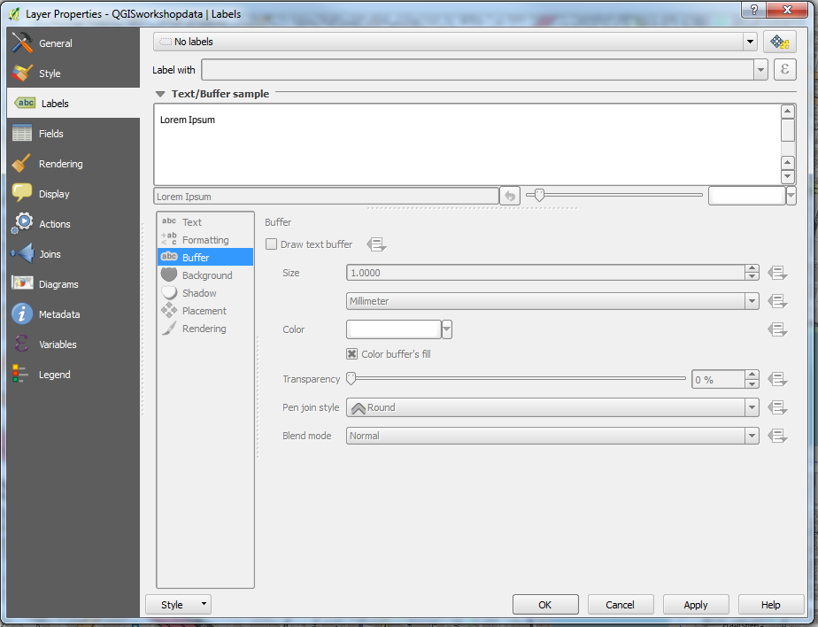

There are several options for generating labels. Select Show labels for this layer

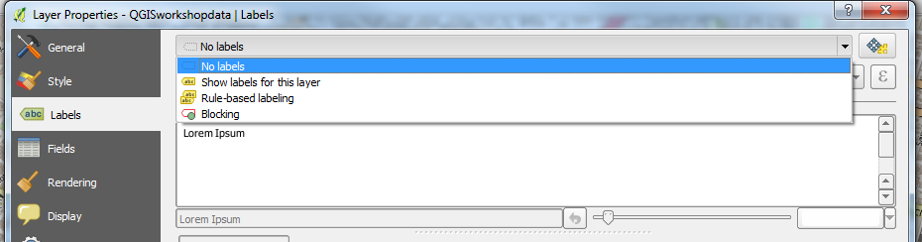

Then select the variable from your table you want to base your labels on.

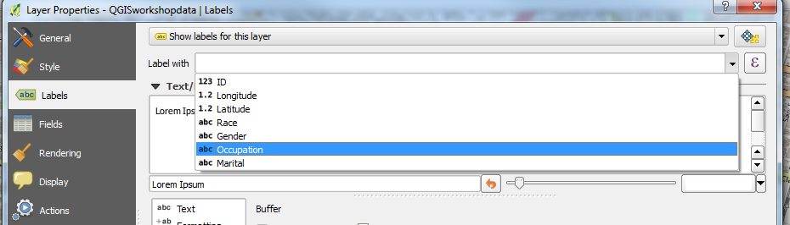

If you want your labels to stand out against the background and/or the basemap, you can enable the Buffer by clicking the box next to Draw text buffer and next to the Color buffer’s fill, with the color selected. Feel free to experiment with the Size of the Buffer.

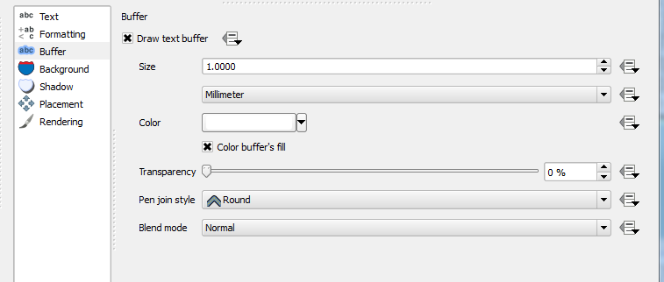

You can also adjust the placement of the label in relation to the feature. The Rendering menu also has some helpful options in terms of duplicate labels and overlapping labels.

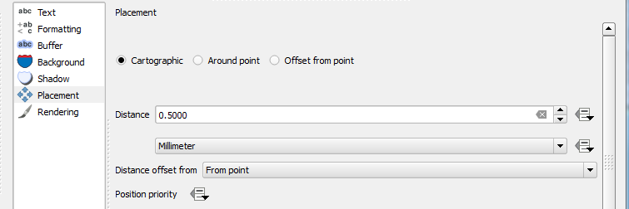

**Adding a Polygon Layer and Creating a Choropleth Map**

You add a shapefile (vector) by clicking on the top button on the left side menu **Add Vector Layer**. This will open the Add vector layer dialog box. Click Browse and navigate to the folder that holds your data.

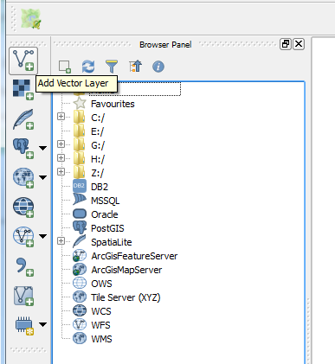 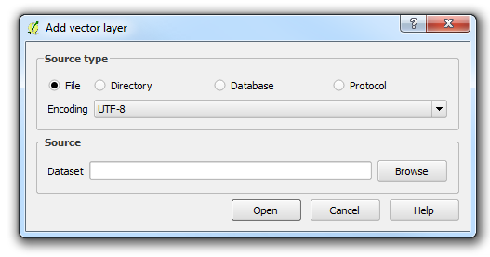

QGIS will list every file in a folder, even if it is not a vector layer. How do we know which one to select? The LandCover_GA files all have a .tif somewhere in their extension. All of these LandCover files support LandCover_GA_wgs.tif But we are not looking to add a raster right now. We are interested in a vector layer. There are 4 files that support a vector layer as part of ACSCty_2014ACS_simplify – with extentions .dbf (the database), .prj (the projection), .shp (the shapefile with the geometry) and the .shx (a support file). An .sbn is another common support file.

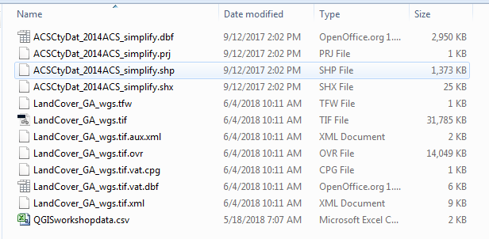

We want to choose the .shp. QGIS will automatically incorporate the supporting files to display our data correctly.

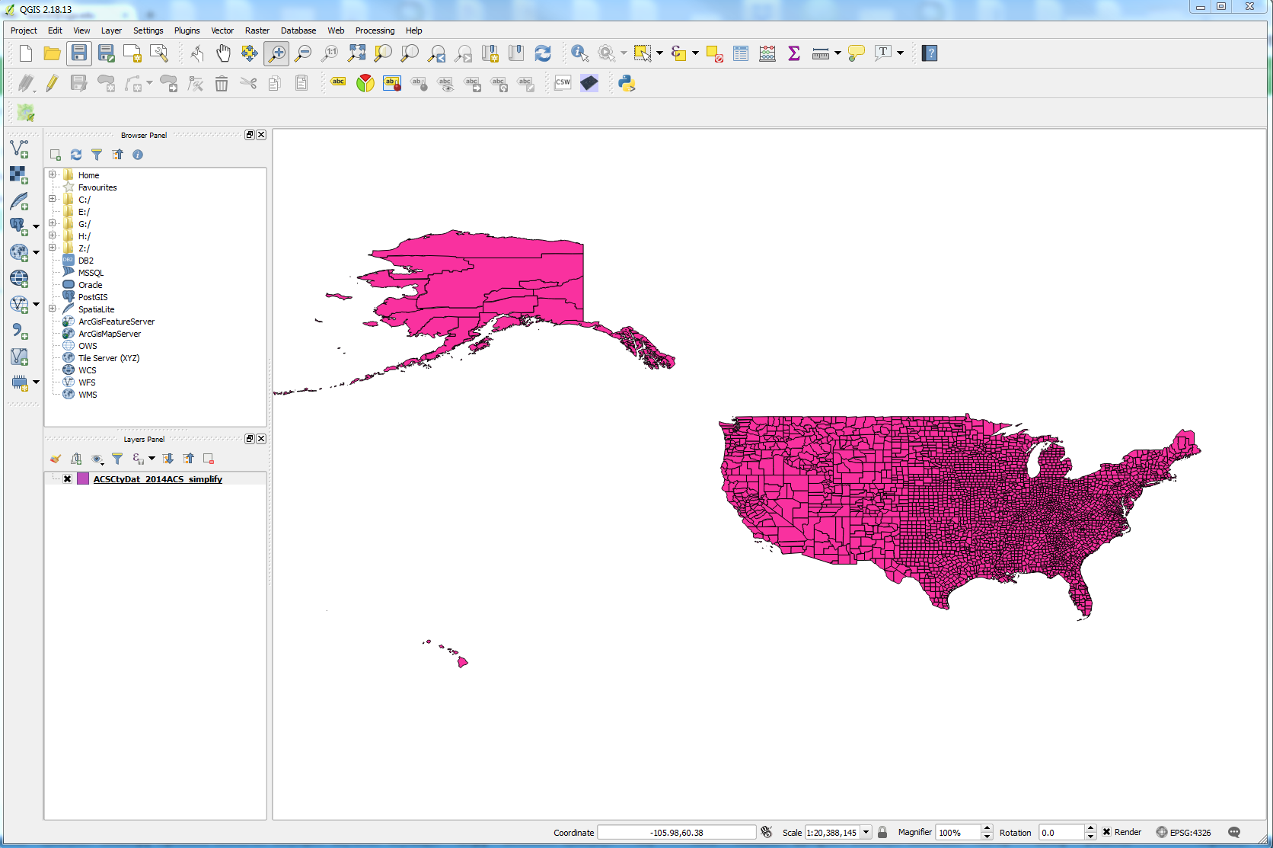

QGIS will randomly assign a color to your polygons. We can change that and incorporate the data in the attribute table into a choropleth map – similar to a heat map, but using geographic boundaries to reflect the statistical measurement of a phenomena. Right click on the name of the file in the **Layers Panel** and select **Properties**

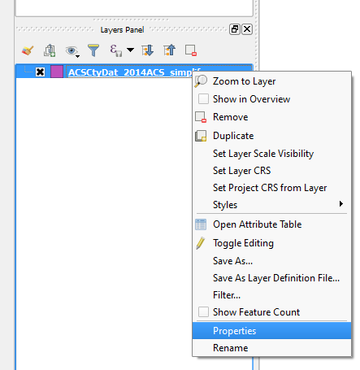

Make sure Style is the menu item highlighted on the left. Single symbol is the default, but there are other options, each with their own style options. Use the dropdown to select Graduated.

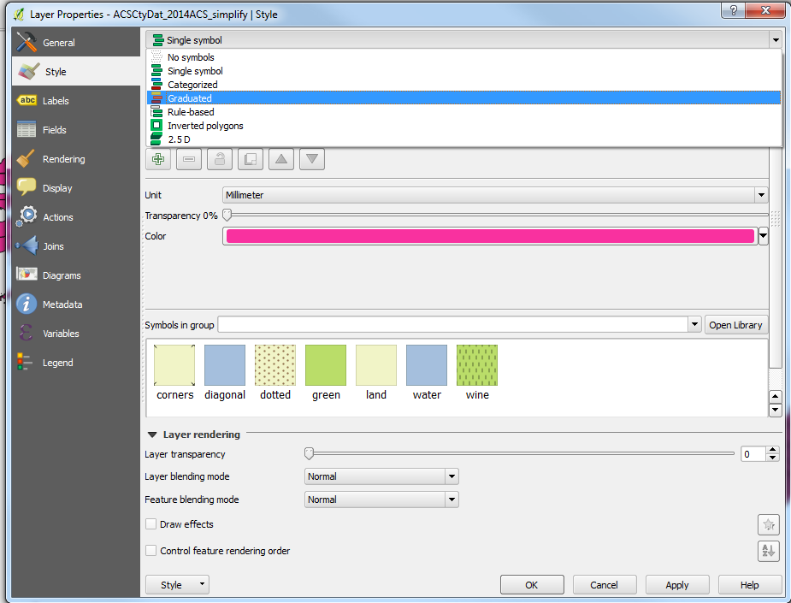

Now your dialog box will look like this:

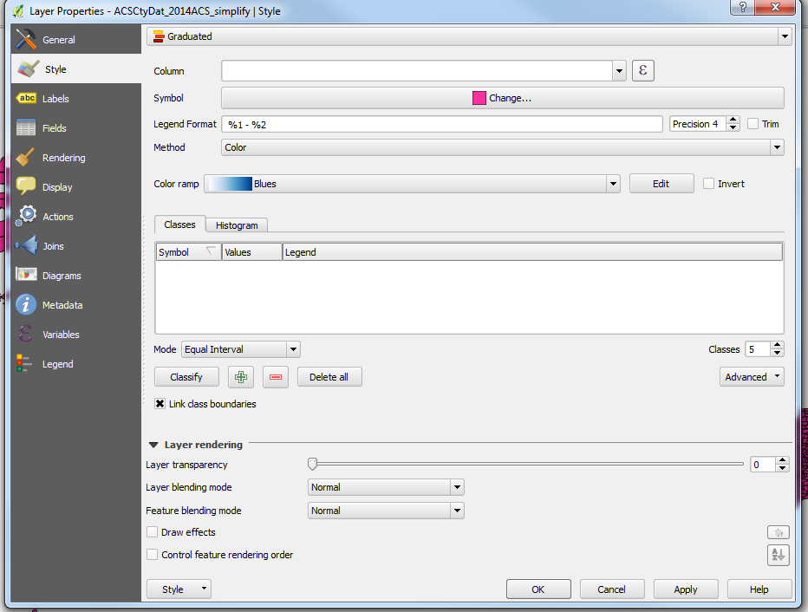

The first thing we select is which column we want to base our choropleth divisions on. For this example, I’m going to choose the GRADDEG_PC – the percent of the population that holds a graduate degree.

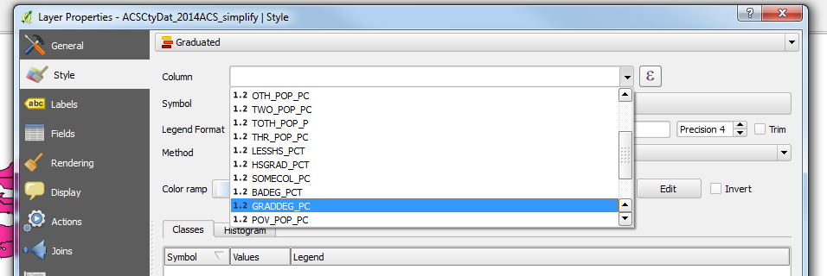

*Expression*

button

If my column wasn’t already a percentage, or I wanted to assign a weight to some of the variables, I could do that using the *Expression* button. Once your column is selected, change the Mode of classification or just click Classify to populate the Symbol, Values, and Legend

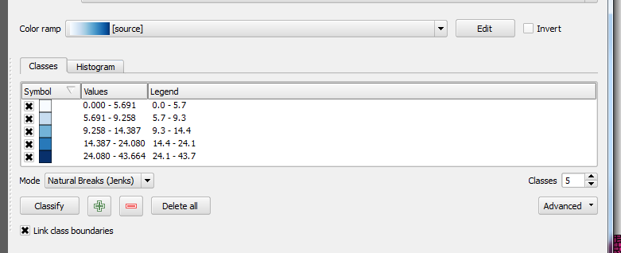

The Symbol is the color for each value that will be displayed on the map. The Values show the breaks between each of the classes, and the Legend shows the values that will be displayed on your map. If there are too many places after a decimal for your taste, you can change that. Precision refers to the number of places after the decimal. You can reduce the number to show fewer decimals on your map. Trim will remove any trailing zeros from the Legend display.

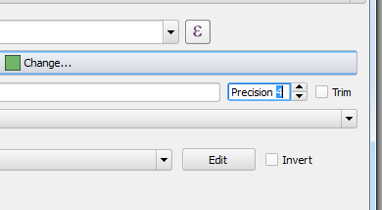

A Precision 0 removes all decimals

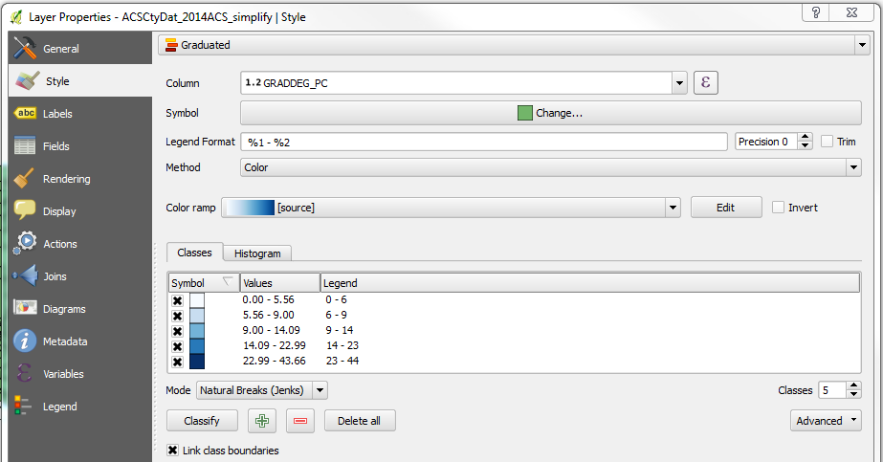

You can also adjust the number of Classes. Beware using too many or too few classes. Too many is hard for people to discern slight color changes, too few and variations/patterns are lost. Click Apply to see what your changes look like and OK, when you are done.

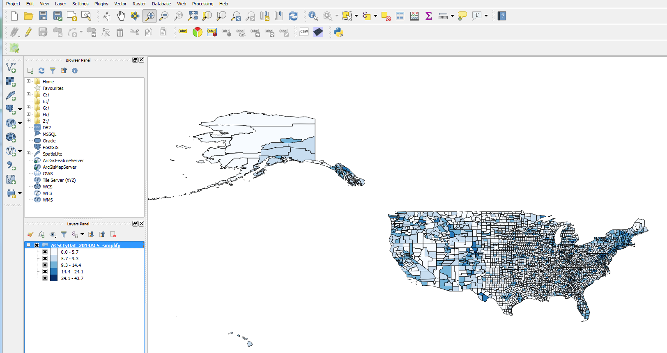

Stylistically, QGIS has a number of options. We can change the color ramp used by using the drop down **Color ramp** menu. But we can also make changes to the outlines of our polygons. On the line for **Symbol**, click on the bar marked **Change…** this will bring up our symbol selector with a Simple Fill in our Symbol selector dialog box.

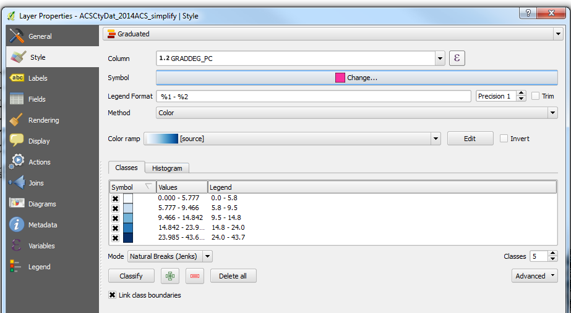

Click on the words Simple Fill and more styling options are revealed.

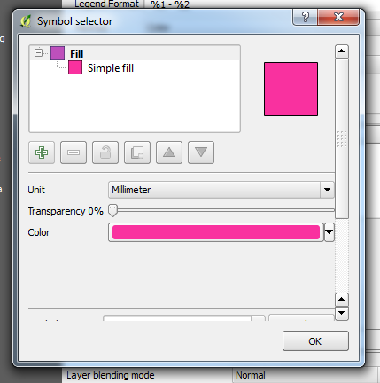 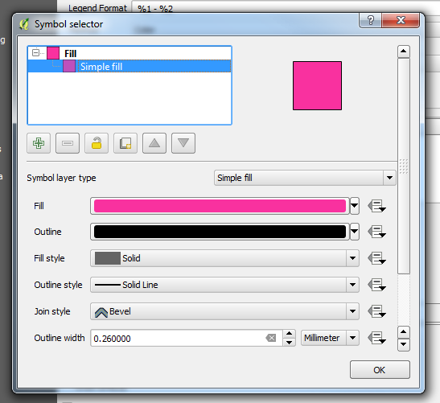

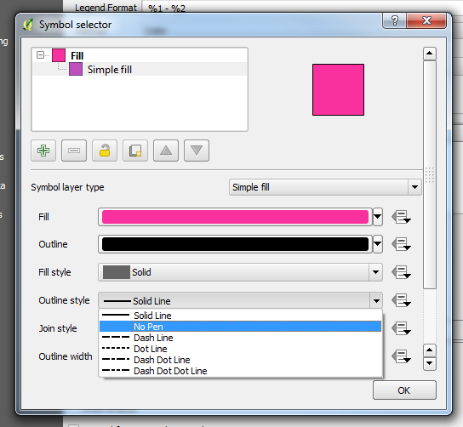

You can change the color of the outline, its fill, width, and style – including dashed lines or no lines at all. Making the changes here, applies the changes to all of the Symbol colors.

If you notice that the first symbol is now showing up as pink (or whatever the default was), just click on Classify and the color will revert to the assigned choropleth color.

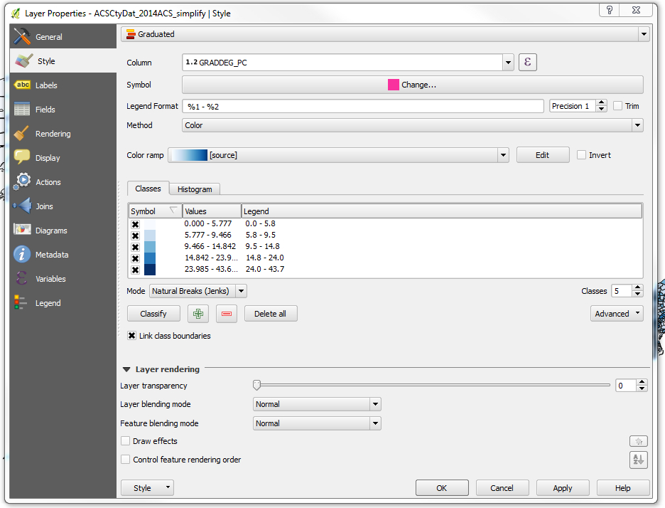

Behold the difference.

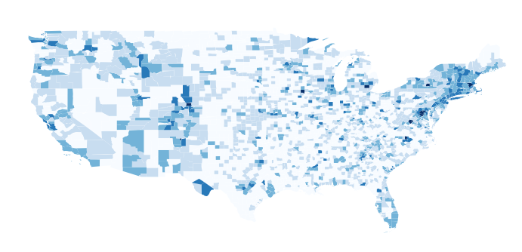

**Print Composer: Putting it all together on a map**

Now we’re ready to put everything on the map. Under Project, select New Print Composer and give your map a name (optional).

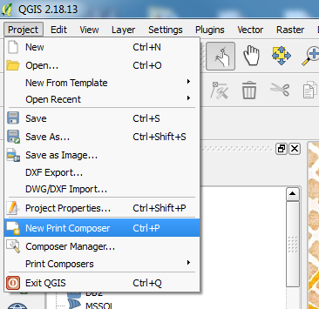

The Print Composer opens as a blank canvas. The buttons along the left hand side will help you built your map. If you hover over them and popup will appear to explain what each does.

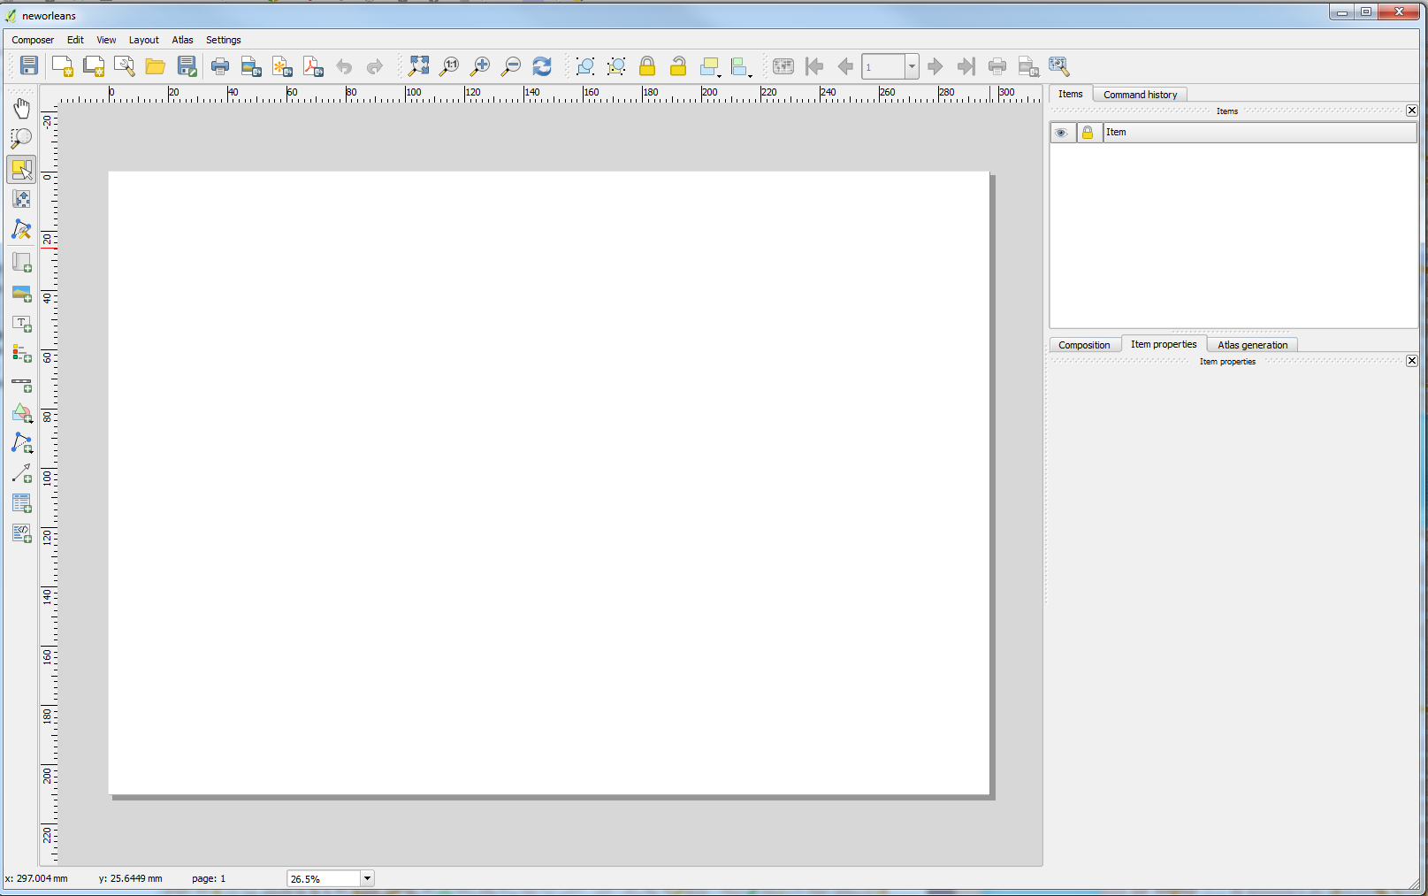

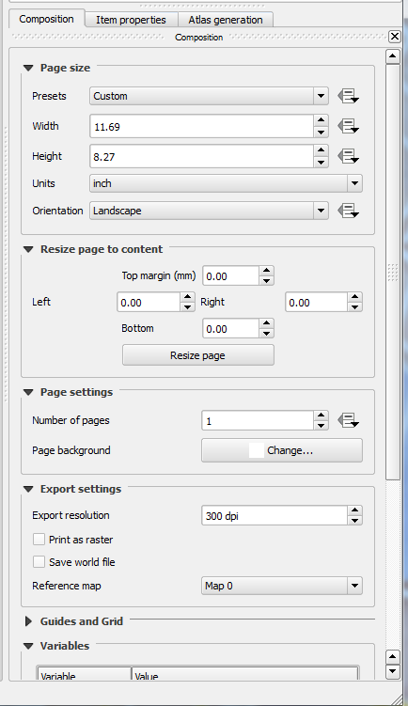

On the right in the middle-ish, there are three tabs. The first is the Composition. This deals with the size and resolution of your map. It’s easier to decide on the size first, but it’s not impossible to change later.

The resolution is important depending on how you are going to use this map. You want at least 300 dpi to avoid pixilation in a jpeg image if you were to enlarge it on a poster.

Now we want to add our map to the map canvas. The sixth button down 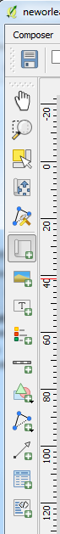 will Add new map. On the map canvas, holding down the left mouse key, draw the size and position of the map and the map will appear from the Project window. You can adjust what’s drawn with the fourth button down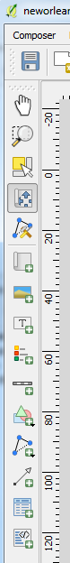. This is Map 0.

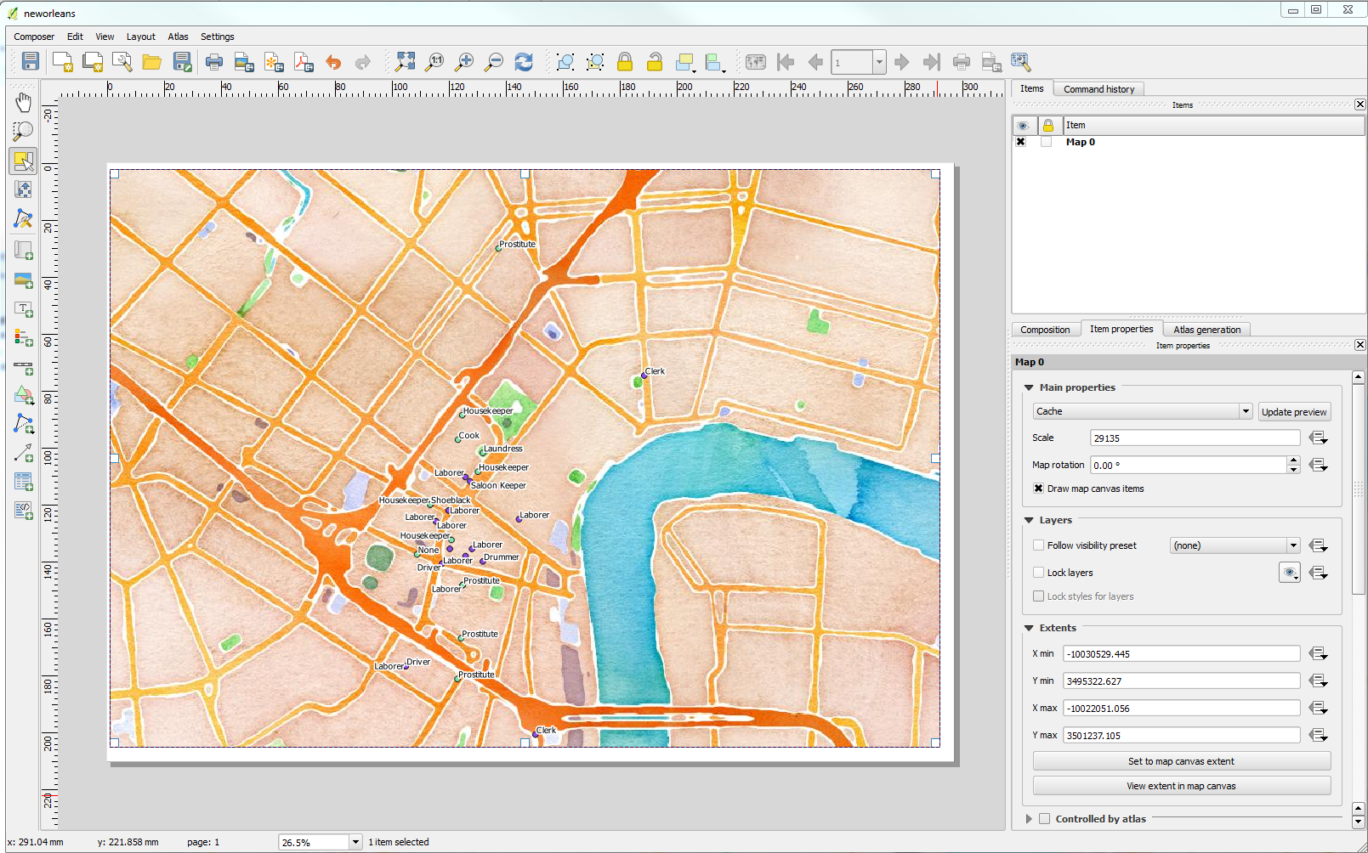

Optional: Inset maps

We can add an inset map to highlight areas on our map that are dense in observations or show where our study site is in a state or county. First **Lock Map 0** by clicking on the box under the Lock next to Map 0 in the Items list, or you will be sorry later.

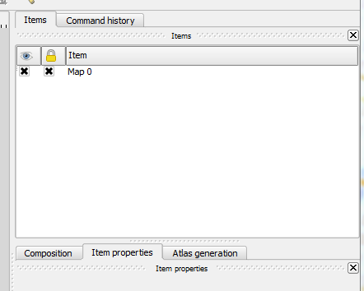

Then go back to your Project window and zoom in on the area you want to show in more detail (or zoom out to show less, or add a shapefile of the state or county your study site is in).

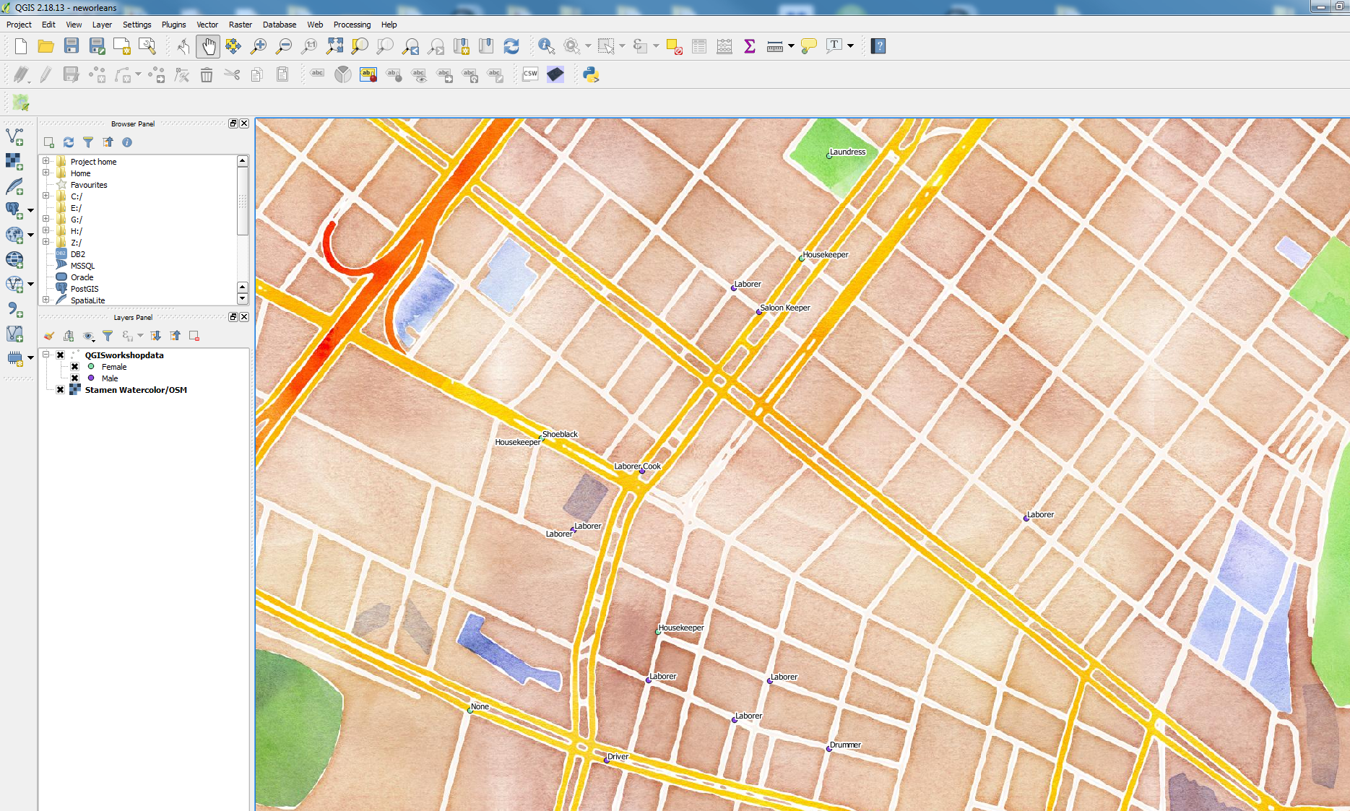

Return to the Print Composer and use the Add new map button and draw the size and position of inset map. This is Map 1.

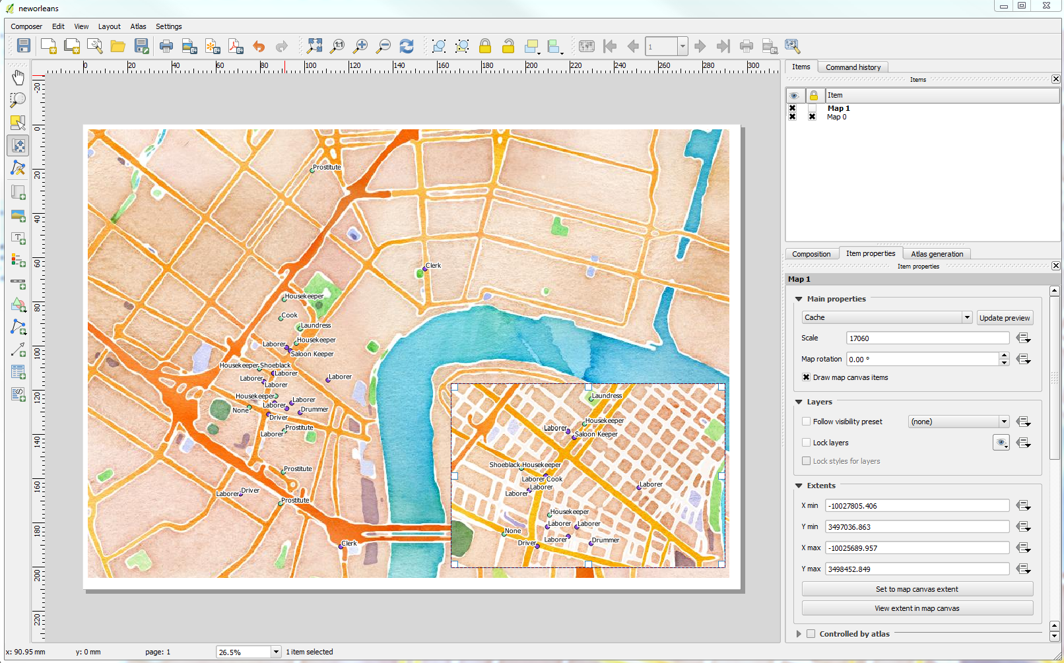

Adding a Title. This is done using the Add new label button in the left hand menu . Hold down the left mouse button and draw the size and location of the title.

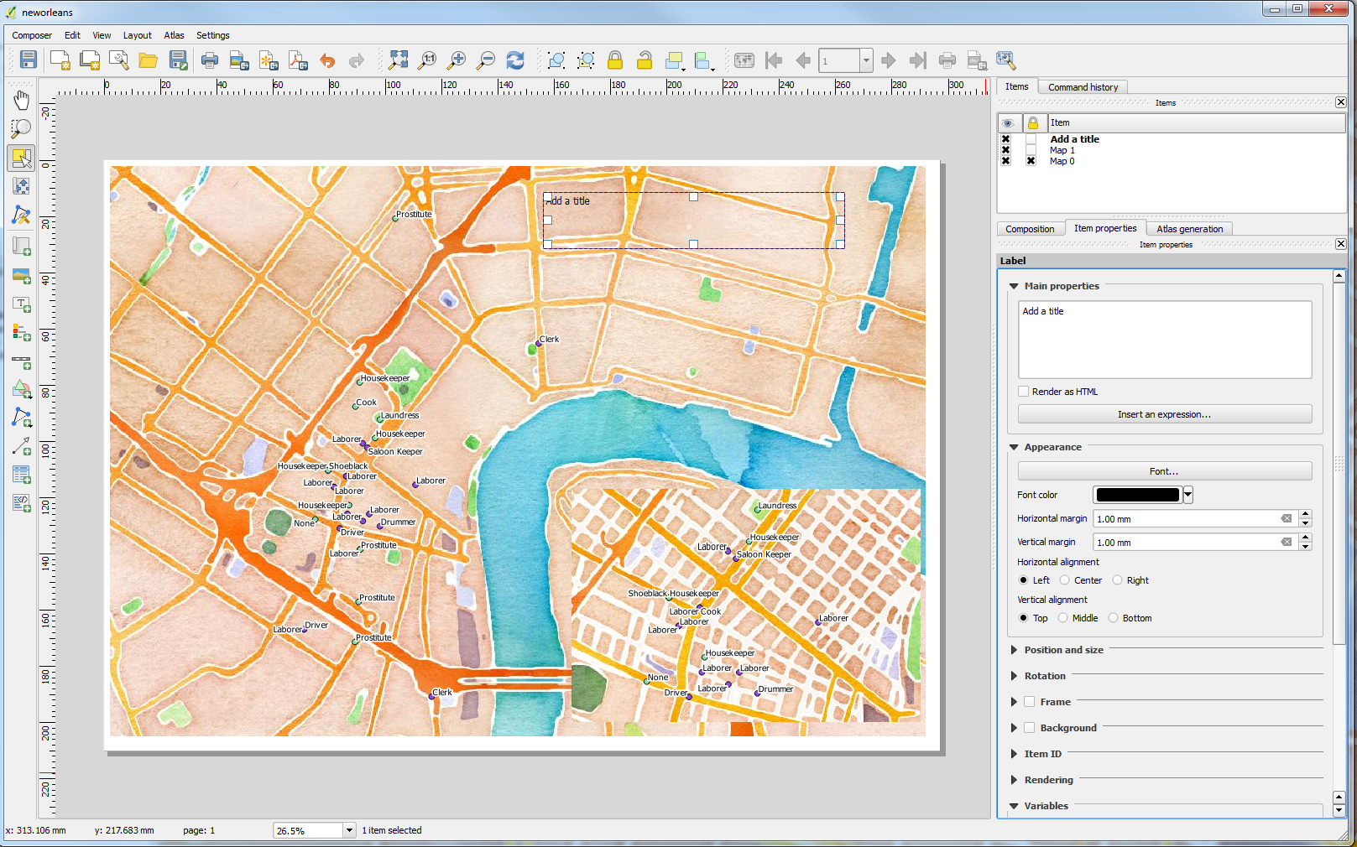

You can add a background color to the title frame by checking the **Background** box, and/or add an outline around the title by checking the **Frame** box. You can also change the **Font** and the **Font color**. Font Size and Style are hidden under the button labelled **Font…**

There are several fonts to choose from and it might take a bit to come up with the right combination of fonts, style, and size for your map.

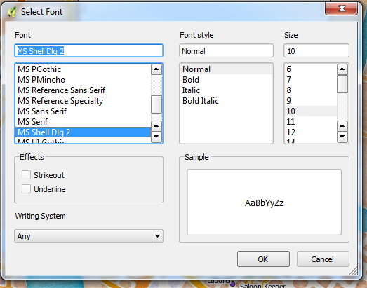

Now we can add the Legend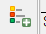 using the Add new legend button. Again draw where you want the legend to go on your map. The legend will autofill with the layers that are turned on in your project.

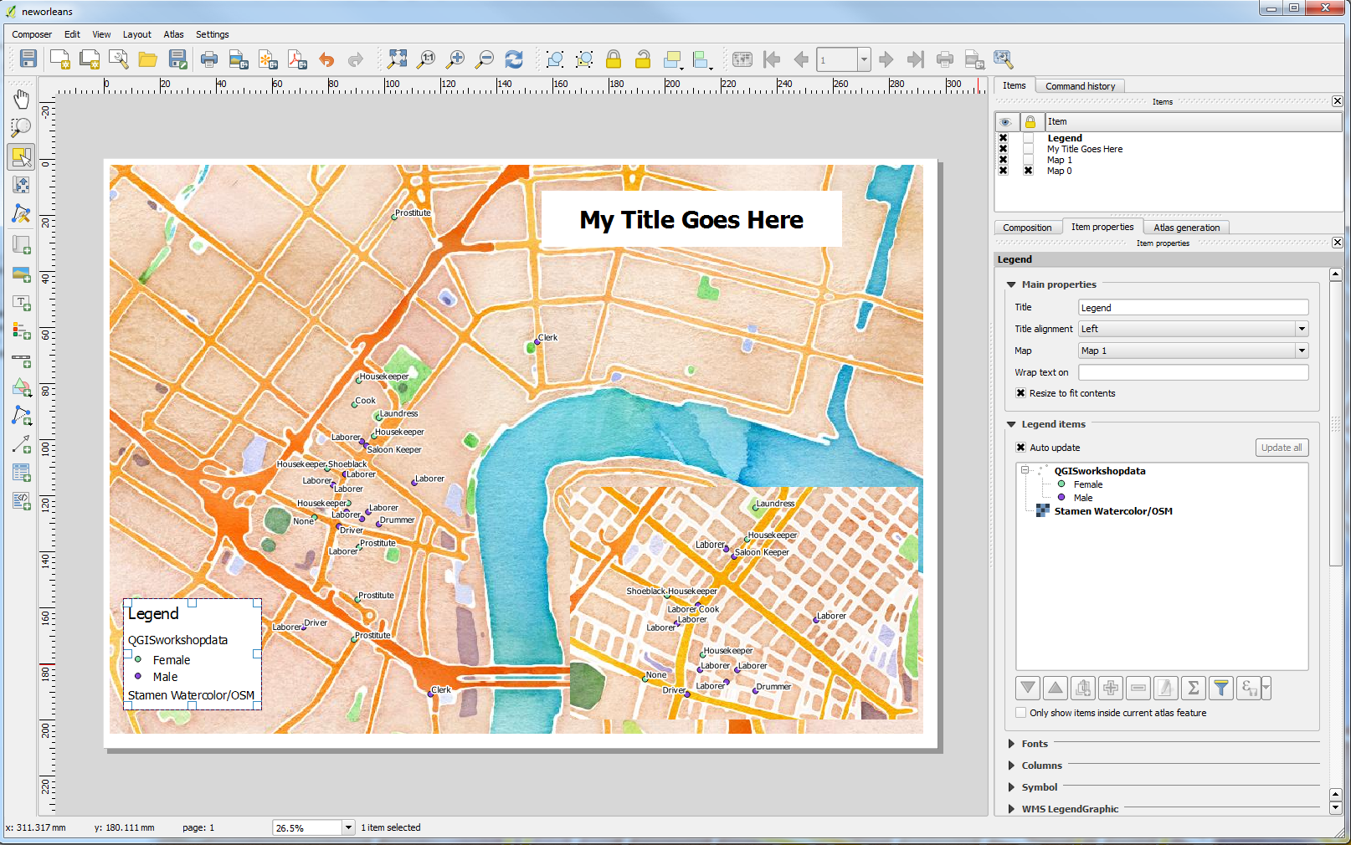

To customize and/or remove unnecessary items from your Legend, first uncheck the Auto update box, this will allow you to use the icons below the Legend Items window to become usable. You can remove items by using the big red minus sign and edit by first clicking on the pencil icon. If you want to hide the name of your shapefile, you can use the pencil icon and your backspace to delete it.

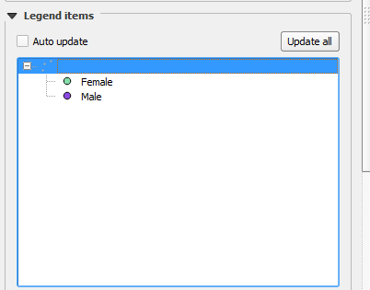

Adding a Neatline around your map (or inset map) can be accomplished with the 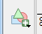 Add shape button. Choose the rectangle and draw it around your map, then use the Style button to Change… the fill to transparent and make the line width thicker.

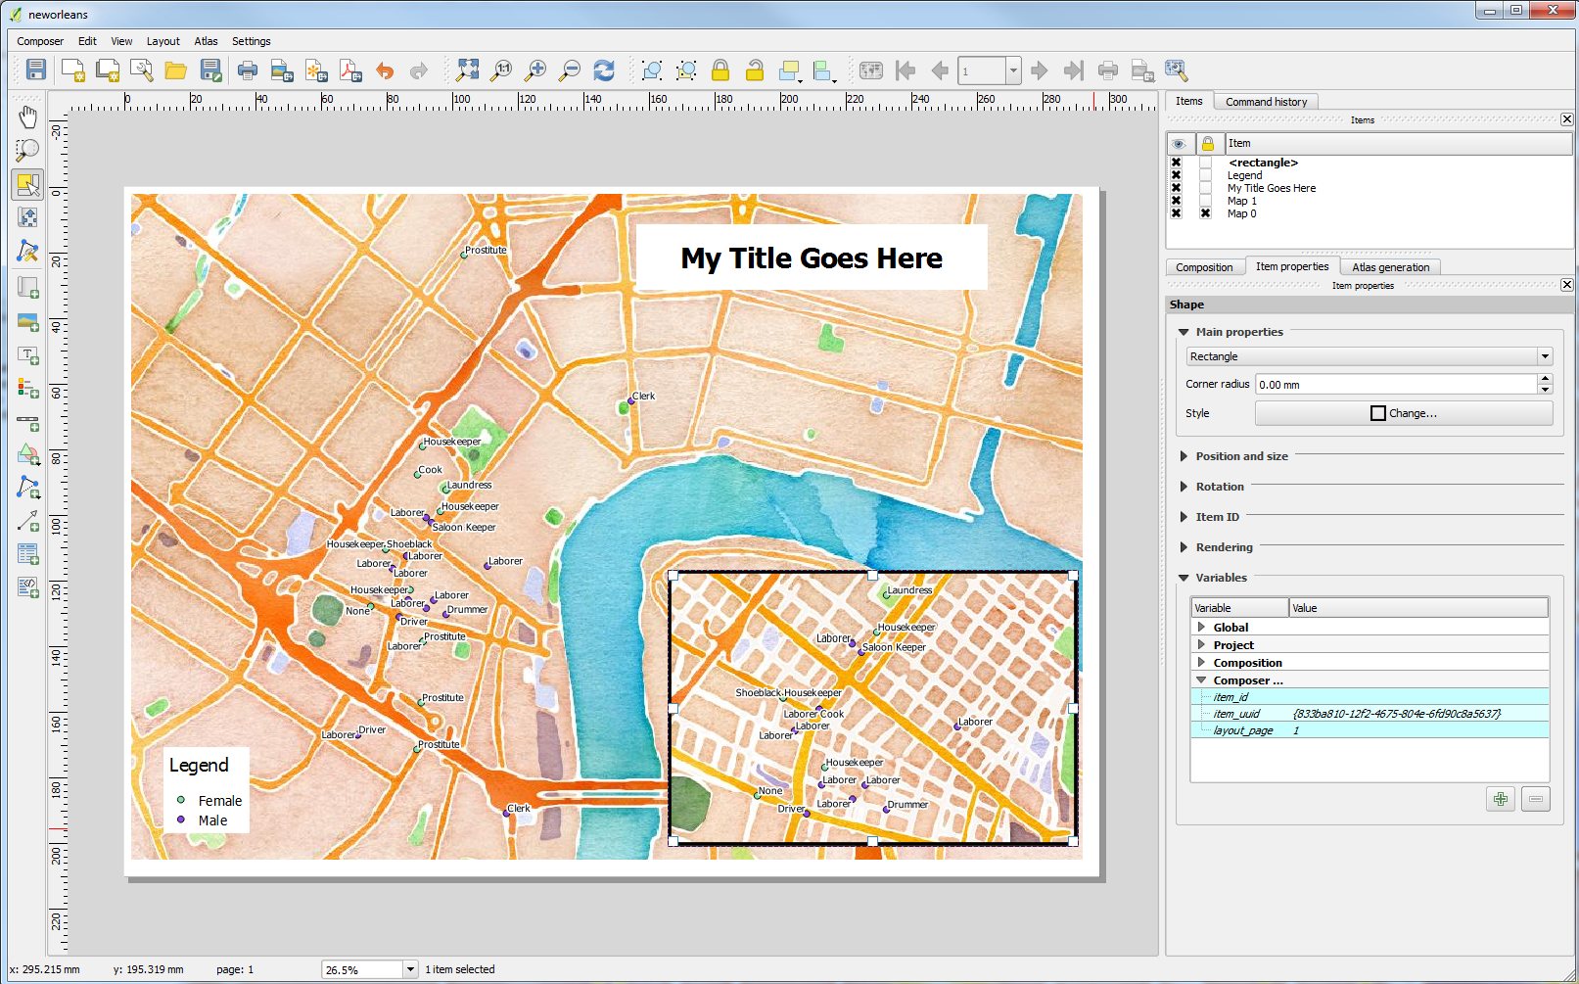

Other elements to consider adding: a scale bar, north arrow, and text box containing the source of your data and the date of the map’s creation.

All done? It’s time to Export your map. There are three shortcuts in the menu bar along the top. Export to an image, an SVG, and as a pdf.

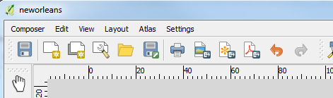

Images are good for inserting as graphics in PowerPoint presentations and for use in posters, SVG for things that end up on the web (Caution: you did not just create a web map, it is a static image that will have no interactivity. If you want to make a web map, that’s another lesson), and pdf for page sized additions to reports and papers.

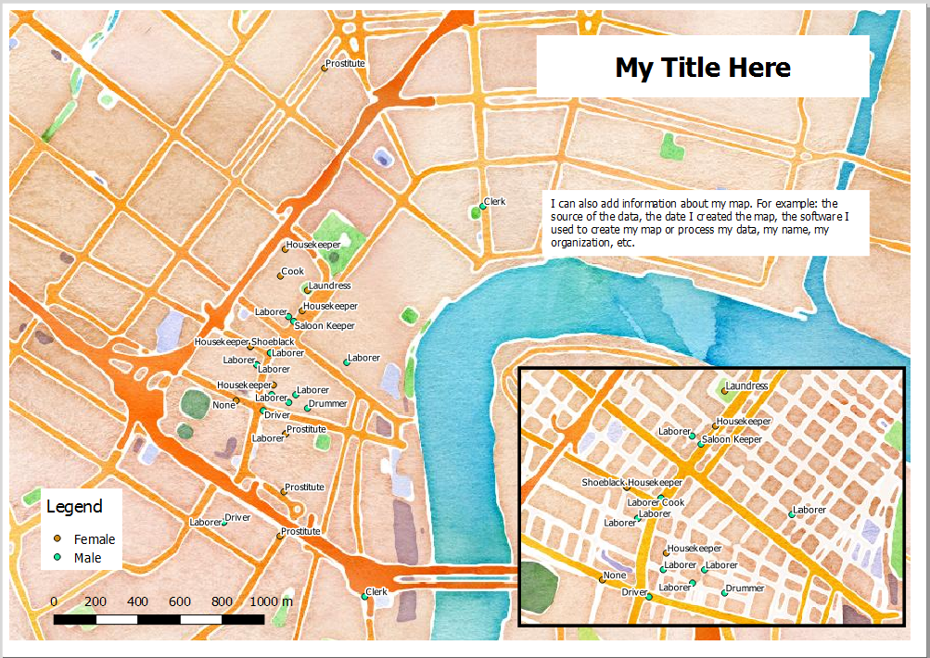

**Creating a print choropleth map**

Add the map to the print composer as above. One thing to pay attention to when adding a Legend to a print of a choropleth map is the heading of the Legend.

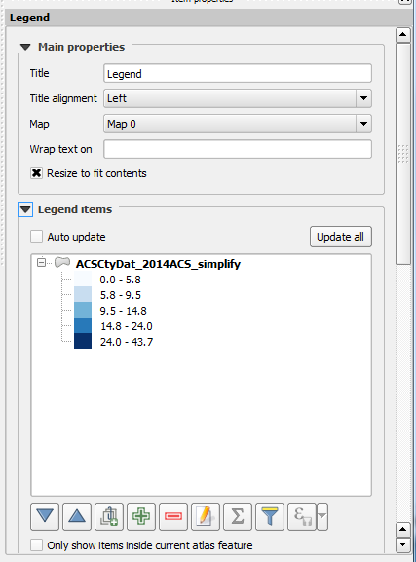

Be sure to turn off Auto Update so you can make changes to your Legend. Then you can click on the pencil icon. QGIS defaults to the name of the file. Click on the name to open the Legend item properties box. Enter the text you would like to display and click OK.

